Society for Computer Technology & Research’s
PUNE INSTITUTE OF COMPUTER TECHNOLOGY



Data Science & Big Data Analytics Lab [310256]
Mini-Project Report on

TweetPulse

Submitted by

[Aditya Dudhagi, Roll No. 31414 ]
[Sukanya Gupta Roll No. 31416 ]

Class: - T.E (2019 course) Branch: -Computer Engineering

ACADEMIC YEAR: 2025-26

TABLE OF CONTENTS

CHAPTER NO. | NAME OF CHAPTER | PAGE NO
 | Introduction | 3
 | Motivation | 4
 | Objective/ Purpose | 5
 | Scope of Project | 6
 | Intended Audience | 7
 | Functional requirements | 8
 | Non-functional requirements | 9
 | Operating Environment | 10
 | Architectural Diagram and Flowchart | 12
10. | Implementation details along with screenshots | 15
11. | Conclusion | 18

CHPATER 1
INTRODUCTION

TweetPulse is a full-stack web application that performs real-time sentiment analysis on textual inputs, particularly tweets and short-form social media text. Built as a Data Science and Big Data Analytics mini-project, it demonstrates end-to-end deployment of a machine learning pipeline — from raw data preprocessing to a live, interactive web interface.

The application uses a Multinomial Naive Bayes classifier trained on over 20,000 tweets, vectorized using the Bag-of-Words (CountVectorizer) technique with unigram and bigram support. The trained model is serialized as a .pkl artifact and served through a FastAPI REST API backend. A custom-built frontend using Vanilla HTML, CSS, and JavaScript consumes this API, displaying sentiment predictions with confidence scores and a glassmorphic user interface.

A key engineering consideration in TweetPulse is the handling of negation — words like "not good" or "never bad" are correctly classified through an override system layered on top of the standard Bag-of-Words model, which typically struggles with such constructs. The system also preserves negation tokens (e.g., "not", "don't", "can't") in its stopword filter to retain linguistic context during classification.

CHPATER 2
MOTIVATION

Social media platforms generate billions of text messages every day. Twitter (now X) alone processes over 500 million tweets per day. Extracting actionable insights from this volume of unstructured text data is a valuable and widely applicable problem in Natural Language Processing (NLP) and Data Science.

The primary motivations behind developing TweetPulse are:

- To apply core NLP and machine learning techniques on real-world social media data, including text preprocessing, feature extraction, and classification.
- To demonstrate the full ML pipeline from data ingestion and model training to production-grade API serving and frontend integration.
- To address a known limitation of Bag-of-Words models — their inability to handle negation — through a custom override mechanism.
- To build an interactive, user-friendly application that makes ML predictions accessible to non-technical users through a modern web interface.
- To explore the use of TextBlob for automated label generation as a semi-supervised labeling approach when ground truth annotations are unavailable.

Sentiment analysis has wide applications in brand monitoring, customer feedback aggregation, financial market prediction, election analysis, and public health monitoring. TweetPulse serves as a practical, demonstrable prototype for such systems.

CHPATER 3
OBJECTIVE / PURPOSE

The objectives of the TweetPulse project are as follows:
- To design and implement a text preprocessing pipeline that cleans raw tweet data by removing URLs, mentions, hashtags, punctuation, and stopwords while preserving negation terms that carry semantic meaning.
- To train a Multinomial Naive Bayes model using the Bag-of-Words representation (CountVectorizer) with unigram and bigram features on a dataset of 20,000 tweets.
- To automate dataset labeling using the TextBlob sentiment polarity score, generating binary labels (positive / negative) for training data.
- To export and serialize the trained ML model and vectorizer as .pkl files for efficient, stateless inference at runtime.
- To build a FastAPI-based REST API backend that loads the serialized model and exposes a POST /predict endpoint for real-time sentiment classification.
- To construct a responsive, visually polished frontend using HTML5, CSS3, and Vanilla JavaScript with glassmorphism aesthetics, animated background elements, and a confidence visualizer.
- To implement an intelligent negation-override system that corrects common Bag-of-Words misclassification patterns such as "not good" (correctly → Negative) and "never bad" (correctly → Positive).
- To provide a health-check endpoint (/health) for server and model status monitoring.

CHAPTER 4
SCOPE OF PROJECT

TweetPulse is scoped as a binary sentiment classifier for English-language short-form text. The following defines the boundaries and capabilities of the current implementation:

In Scope
- Binary sentiment classification: Positive or Negative output for any given English text input.
- Text preprocessing including lowercasing, URL/mention/hashtag removal, contraction expansion (e.g., n't → not), and selective stopword removal.
- Negation-aware overrides for common false-classification patterns.
- Real-time inference via a REST API (POST /predict) returning sentiment label and confidence probability.
- Web-based user interface for interactive sentiment testing without any technical setup by the end user.
- Model retraining capability via the train_and_export.py script whenever new data or parameters are needed.

Out of Scope
- Multi-class sentiment analysis (e.g., Neutral, Very Positive, Very Negative) is not supported in the current version.
- Non-English language support is not included.
- Real-time Twitter/X API integration (live tweet streaming) is not implemented — the tool accepts manually entered text.
- User authentication, session management, and persistent storage of query history are not implemented.
- Deployment to a production cloud environment (e.g., AWS, GCP, Azure) is outside the current scope.

CHAPTER 5
INTENDED AUDIENCE

TweetPulse is designed to serve a variety of users and stakeholders:

Audience | Use Case
Students & Researchers | Studying NLP, machine learning pipelines, and sentiment analysis techniques as a hands-on reference implementation.
Data Scientists | Exploring the application of Naive Bayes and CountVectorizer for text classification and using the project as a deployment template.
Product Managers & Analysts | Performing quick sentiment assessments on customer feedback, product reviews, or social media mentions.
Educators | Demonstrating a complete ML project lifecycle — data processing, model training, API serving, and frontend integration — in a classroom setting.
Developers | Using the FastAPI backend as a template for building ML-as-a-service APIs with serialized scikit-learn models.

CHAPTER 6
FUNCTIONAL REQUIREMENTS

The following table describes each functional component of TweetPulse:

Function | Description
Text Input | The user enters any English text (tweet, sentence, or phrase) into the web interface text box. No character limit is enforced by the UI.
Text Preprocessing | The system converts input to lowercase, expands contractions (n't → not), strips URLs, @mentions, #hashtags, and non-alphabetic characters, then removes stopwords while preserving negation words.
Negation Override | A regex-based pattern matcher checks for negation + positive/negative keyword combinations before invoking the ML model, ensuring correct classification of phrases like 'not good' or 'never bad'.
Sentiment Prediction | The cleaned text is vectorized using the loaded CountVectorizer and passed to the Multinomial Naive Bayes model. The system returns a binary label: Positive or Negative.
Confidence Score | Where supported (model.predict_proba), the system returns the maximum class probability as the confidence score, displayed as a percentage bar in the UI.
API Health Check | A GET /health endpoint returns the API server status and confirms whether the ML model is successfully loaded.
CORS Support | The FastAPI backend allows cross-origin requests (CORS enabled for all origins) so the frontend can communicate freely with the API.
Error Handling | If the model fails to load or prediction encounters an exception, the API returns a descriptive error message rather than crashing.
CHAPTER 7
NON-FUNCTIONAL REQUIREMENTS

Performance
- The system should return a sentiment prediction within 500 milliseconds for standard text inputs under normal load conditions.
- Model loading occurs once at server startup, ensuring zero model-load overhead per request.
- The CountVectorizer is limited to 5,000 features (max_features=5000) to balance accuracy and inference speed.
Reliability
- The FastAPI application must handle malformed or empty input without crashing, returning appropriate error responses.
- Model and vectorizer loading are wrapped in try/except blocks, allowing the server to start even if .pkl files are missing (with a clear warning logged).
Usability
- The frontend must be usable without any technical knowledge — a single text box and button is the complete interaction model.
- Sentiment results and confidence percentages must be displayed clearly and immediately after submission.
- The UI must be responsive and functional on standard desktop web browsers.
Maintainability
- The training pipeline is isolated in train_and_export.py, allowing the model to be retrained and replaced without modifying the API code.
- The preprocessing logic (clean_text function) is duplicated identically between main.py and train_and_export.py to ensure train-serve consistency.
Security
- The API does not process or store user-submitted data beyond the scope of a single request.
- In a production environment, CORS origins should be restricted to the known frontend domain (currently set to wildcard for development convenience).
- No user authentication data, credentials, or sensitive information are transmitted or stored.

CHAPTER 8
OPERATING ENVIRONMENT

Software Requirements
Component | Requirement | Version
Runtime Language | Python | 3.9 or higher
Web Framework | FastAPI | Latest stable
ASGI Server | Uvicorn | Latest stable
ML Library | Scikit-learn | 1.3.2 (pinned)
NLP Utilities | NLTK | Latest stable
Sentiment Labeling | TextBlob | Latest stable
Data Processing | Pandas | Latest stable
Model Serialization | Joblib | Latest stable
Schema Validation | Pydantic | Latest stable (v2)
Frontend | HTML5 / CSS3 / JavaScript | Vanilla (no framework)
Browser | Chrome, Firefox, Edge, Safari | Any modern version
Package Manager | pip | 3.9+ bundled pip

Hardware Requirements
Component | Minimum | Recommended
Processor | Intel Core i3 / AMD Ryzen 3 | Intel Core i5 or better
RAM | 4 GB | 8 GB or more
Storage | 500 MB free space | 1 GB (for dataset + venv)
Network | Not required for local use | Required for package installation
Operating System | Windows 10 / Ubuntu 18.04 / macOS 10.15 | Windows 11 / Ubuntu 22.04 / macOS 13+

Directory Structure
DSBDAL_mini_project/
├── data_analysis.csv → Tweet dataset (training data)
├── tweet.ipynb → Exploratory analysis notebook
├── train_and_export.py → Model training and export script
├── backend/
│ ├── main.py → FastAPI server and prediction endpoint
│ ├── requirements.txt → Python dependencies
│ ├── model.pkl → Serialized Naive Bayes classifier
│ └── vectorizer.pkl → Serialized CountVectorizer
└── frontend/
├── index.html → Main web interface
├── styles.css → Glassmorphism styling and animations
└── app.js

CHAPTER 9
ARCHITECTURAL DIAGRAM AND FLOWCHART

System Architecture
TweetPulse follows a three-tier architecture consisting of a Presentation Layer (Frontend), an Application Layer (FastAPI Backend), and a Model Layer (Serialized ML Artifacts).

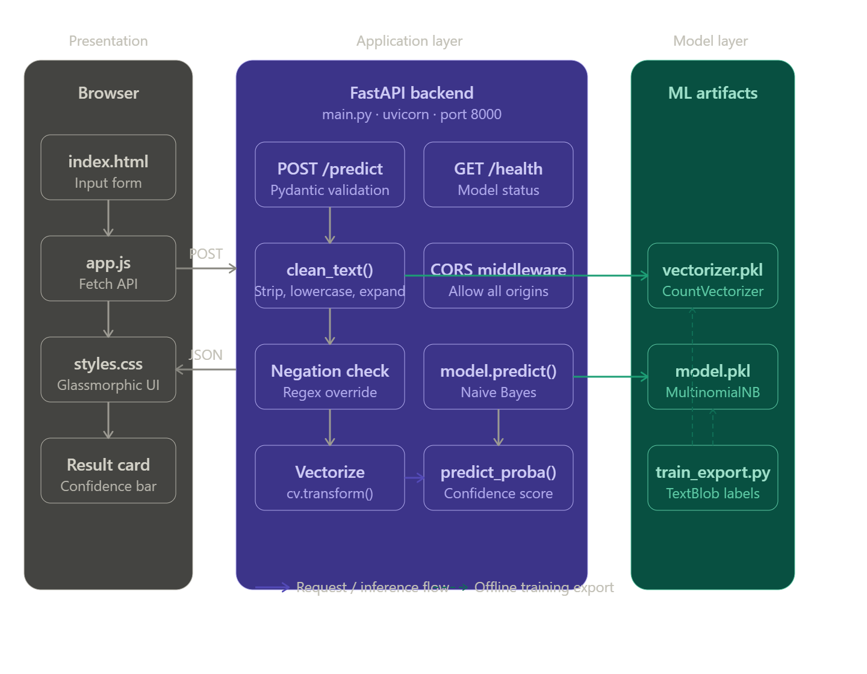
The user interacts with the HTML/CSS/JS frontend running in the browser. On submitting a text input, the frontend sends an HTTP POST request (via the Fetch API) to the FastAPI backend. The backend preprocesses the text, applies the negation override rules, and passes the cleaned input to the loaded Naive Bayes model. The prediction and confidence score are returned as a JSON response, which the frontend displays dynamically.

ML Pipeline Architecture

Stage | Component | Details
1. Data Ingestion | Pandas read_csv | Loads data_analysis.csv; samples 20,000 rows if larger
2. Text Cleaning | clean_text() | Lowercase, contract expand, strip URLs/mentions/hashtags
3. Label Generation | TextBlob | Polarity > 0 = Positive, else Negative
4. Encoding | LabelEncoder | Encodes positive=1, negative=0
5. Feature Extraction | CountVectorizer | max_features=5000, ngram_range=(1,2)
6. Model Training | MultinomialNB | Trained on 80/20 train-test split
7. Serialization | Joblib | Exports model.pkl and vectorizer.pkl

API Request Flowchart

The following describes the step-by-step processing flow for a POST /predict request:

- User types text in the frontend and clicks 'Analyze Sentiment'.
- JavaScript sends HTTP POST to http://localhost:8000/predict with JSON body {"text": "..."}
- FastAPI receives the request and validates it via Pydantic (TweetInput model).
- clean_text() is applied: lowercase → expand contractions → remove URLs/mentions/hashtags → remove stopwords (preserving negation words).
- Negation override regex check: if pattern matches 'negation_word + positive/negative_word', return overridden label immediately.
- CountVectorizer transforms the cleaned text into a sparse feature vector (1 x 5000 array).
- MultinomialNB.predict() returns class label (0 or 1).
- predict_proba() extracts confidence score (max probability of predicted class).
- JSON response {sentiment, confidence, message} sent back to frontend.
- Frontend renders animated result card with color-coded label (green = Positive, red = Negative) and confidence progress bar.

CHAPTER 10
IMPLEMENTATION DETAILS

1. Data Preprocessing — clean_text()
The text preprocessing function is a critical and shared component used identically during both model training (train_and_export.py) and inference (main.py). This ensures train-serve consistency — the model always sees the same representation of text it was trained on.

The pipeline performs the following transformations in sequence:
- Lowercase conversion: Normalizes all characters to lowercase to prevent case-sensitive mismatches (e.g., 'Good' and 'good' treated identically).
- Contraction expansion: Replaces n't patterns with " not" using regex (re.sub(r"n['']t\b", " not", text)) to ensure negation tokens are preserved.
- URL removal: Strips http/https URLs to eliminate noise from web links.
- Mention removal: Removes @username tokens that carry no semantic sentiment value.
- Hashtag removal: Strips #tag tokens for the same reason.
- Non-alphabetic removal: Removes all characters except letters and spaces to eliminate punctuation, numbers, and emojis.
- Selective stopword removal: Uses NLTK English stopwords minus a custom set of negation words (not, never, no, nor, cannot, don't, didn't, isn't, etc.) to preserve sentiment-reversing tokens.

2. Model Training — train_and_export.py
The model training script performs the following steps:
- Loads the tweet dataset from data_analysis.csv using Pandas.
- Samples up to 20,000 tweets (random_state=42) for training efficiency.
- Applies the clean_text pipeline to produce the clean_tweet column.
- Generates binary sentiment labels using TextBlob: polarity > 0 → positive, otherwise → negative.
- Encodes labels with LabelEncoder (positive=1, negative=0).
- Extracts features using CountVectorizer with max_features=5000 and ngram_range=(1,2) to capture both individual words and two-word phrases.
- Splits the dataset 80/20 into training and test sets.
- Trains a MultinomialNB classifier on the training split.
- Reports test accuracy using accuracy_score.
- Serializes both the model and vectorizer to backend/model.pkl and backend/vectorizer.pkl using Joblib.

3. API Backend — main.py (FastAPI)
The FastAPI backend is the core serving layer of TweetPulse. Key implementation details include:
- Model Loading: Both model.pkl and vectorizer.pkl are loaded at server startup using joblib.load(). If loading fails, the server starts gracefully with model=None and returns descriptive error messages rather than crashing.
- CORS Middleware: CORSMiddleware is added to allow the HTML frontend (served from the filesystem or a different origin) to make API requests.
- Pydantic Models: TweetInput (request) and SentimentOutput (response) are defined as Pydantic BaseModel classes, enabling automatic request validation and response serialization.
- Negation Override: Before invoking the ML model, the API applies regex patterns to detect and correctly classify negation constructs that Bag-of-Words typically mishandles.
- Confidence Extraction: predict_proba() is called and the maximum class probability is returned. If the model does not support probability estimates, confidence is returned as null.
- Health Endpoint: GET /health returns {"status": "ok", "model_loaded": true/false} for monitoring.

4. Frontend — HTML/CSS/JavaScript
The frontend is a single-page application implemented in Vanilla HTML5, CSS3, and JavaScript with no external framework dependencies. Key design and implementation features include:
- Glassmorphic UI: Frosted-glass card effect using CSS backdrop-filter: blur() over animated gradient background blobs, providing a modern, premium aesthetic.
- API Integration: The JavaScript Fetch API makes asynchronous POST requests to /predict with a JSON body and handles the response to update the DOM.
- Confidence Visualizer: A CSS progress bar displays the confidence percentage returned by the API, providing users with a quantitative sense of prediction certainty.
- Success/Error State Transitions: The UI transitions between a neutral, positive (green), and negative (red) state with smooth CSS animations based on the API response.
- No Build Step Required: The frontend requires no compilation, bundling, or Node.js — simply open index.html in a browser while the backend API is running.

CHAPTER 11
CONCLUSION

TweetPulse successfully demonstrates the complete lifecycle of a machine learning application — from raw data processing and model training to REST API deployment and interactive frontend integration. The project validates the effectiveness of the Multinomial Naive Bayes classifier combined with Bag-of-Words (CountVectorizer) feature extraction for binary sentiment classification of social media text.

The key technical achievements of this project include:
- A robust, negation-aware text preprocessing pipeline that preserves semantic context otherwise lost in standard stopword removal.
- An intelligent negation override system that corrects known limitations of the Bag-of-Words model for phrases like 'not good' or 'never bad'.
- A production-style API architecture using FastAPI with Pydantic validation, CORS support, error handling, and a health monitoring endpoint.
- A visually polished, fully functional frontend that requires no framework or build toolchain, making the project accessible and easy to demonstrate.

The project demonstrates that even classical machine learning algorithms — when combined with careful preprocessing, domain-aware feature engineering, and thoughtful edge case handling — can produce reliable and useful NLP systems. TextBlob-based automated labeling also proved effective as a semi-supervised labeling strategy when manually annotated training data is unavailable.

Future enhancements could include multi-class sentiment (Positive, Neutral, Negative), integration with the live Twitter/X API for real-time stream analysis, replacement of the Naive Bayes model with a transformer-based model (e.g., BERT) for improved accuracy, and deployment to a cloud platform for public accessibility.

